**SHELL – UNEXT TRAINING**

**CASE STUDY DOCUMENTATION (06/09/2024)**

*By Chitteshwari Satish*

* **TASK 1: CREATION OF VIRTUAL MACHINE USING AZURE**

Create a virtual machine by following the proper steps and settings to be chosen such as the Resource group, area zone, disc size, network group.

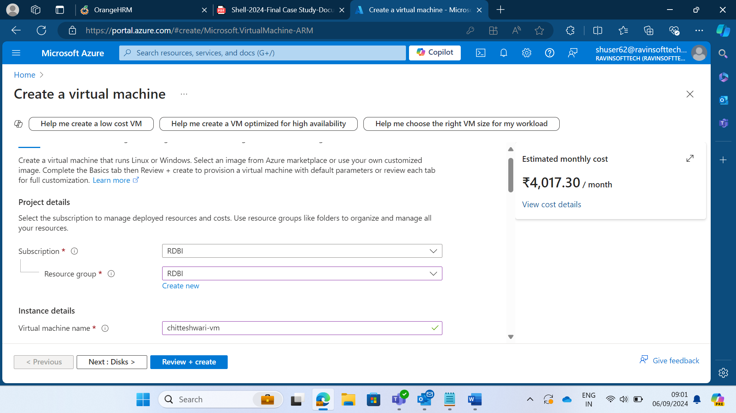

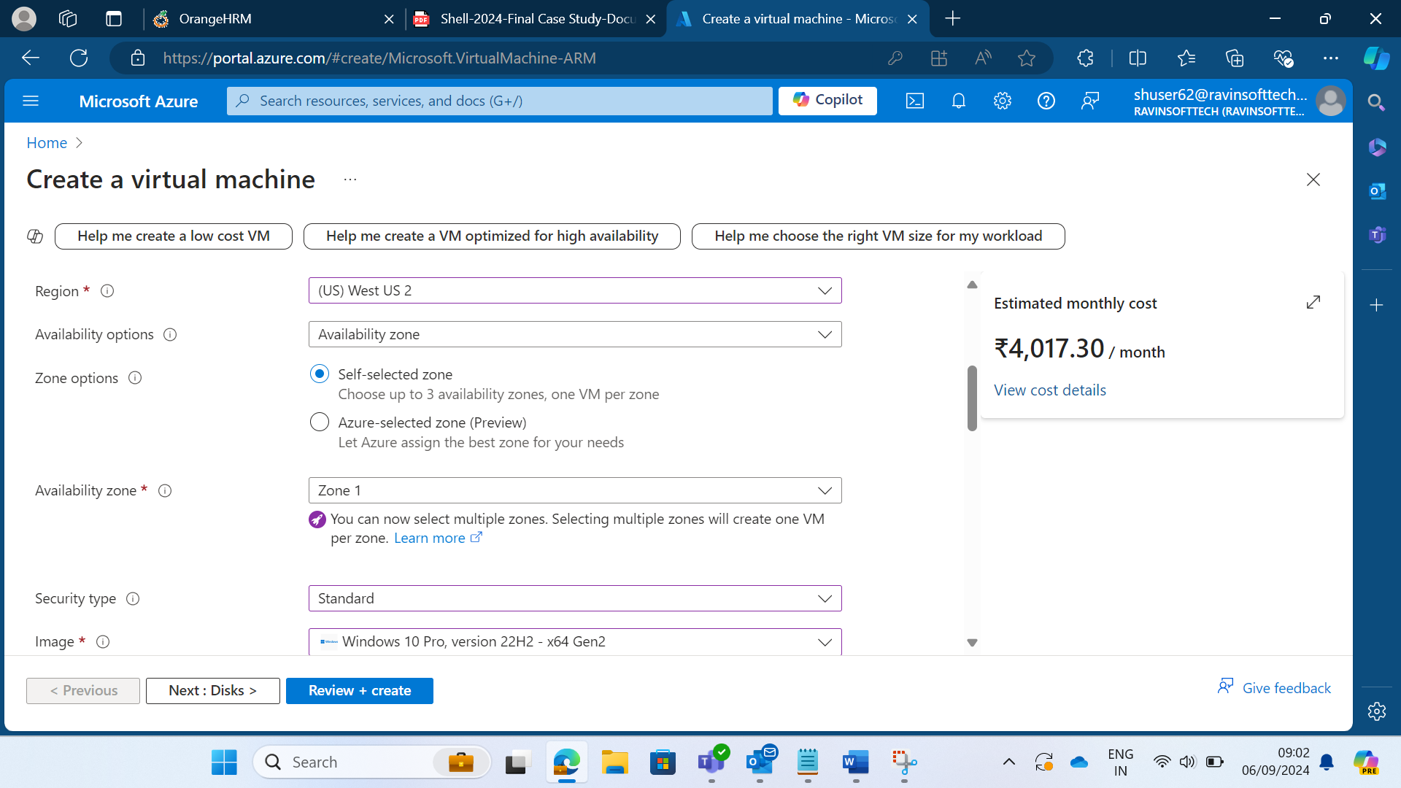

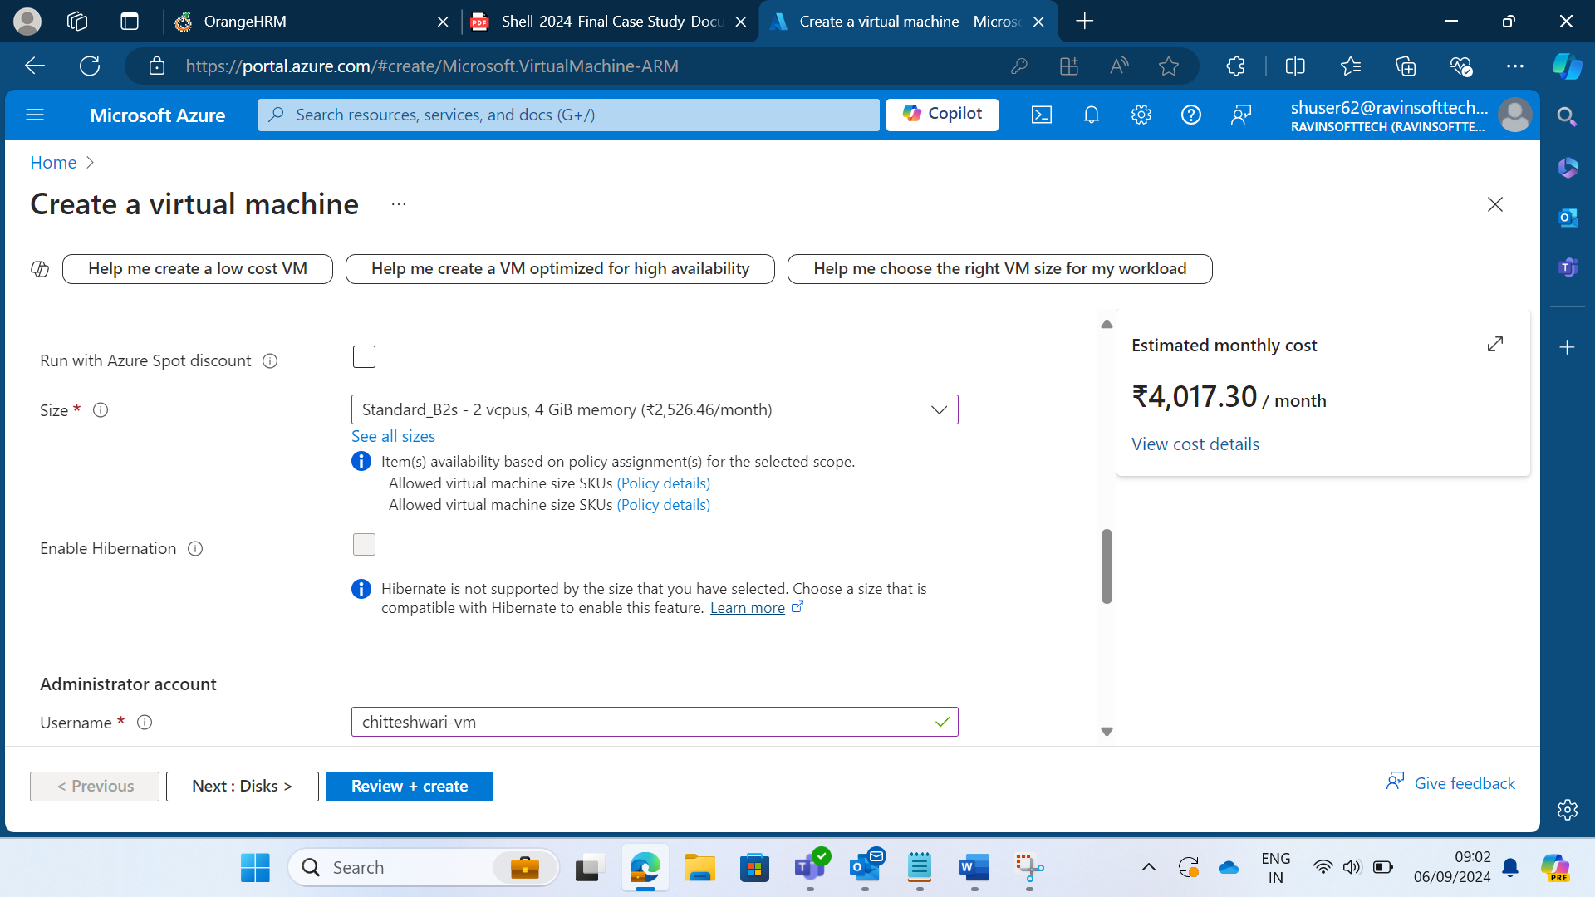

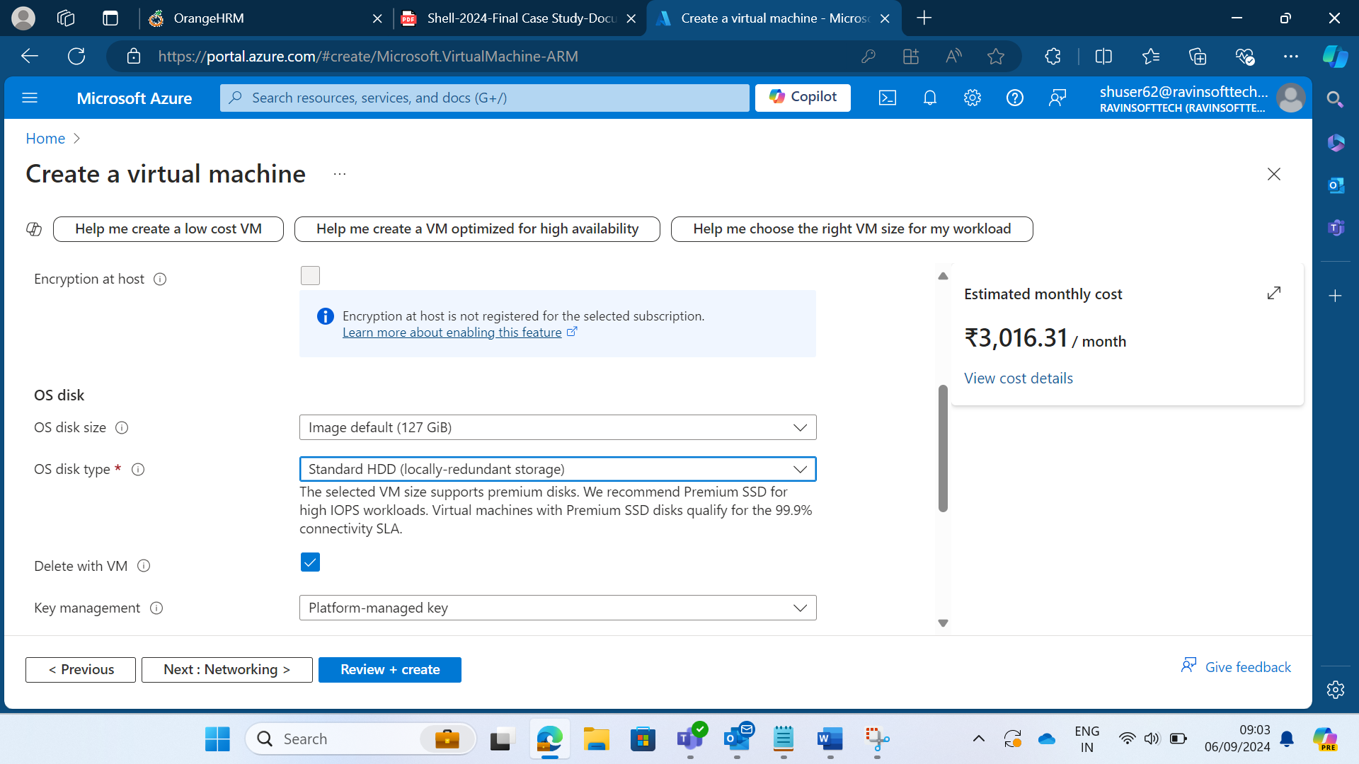

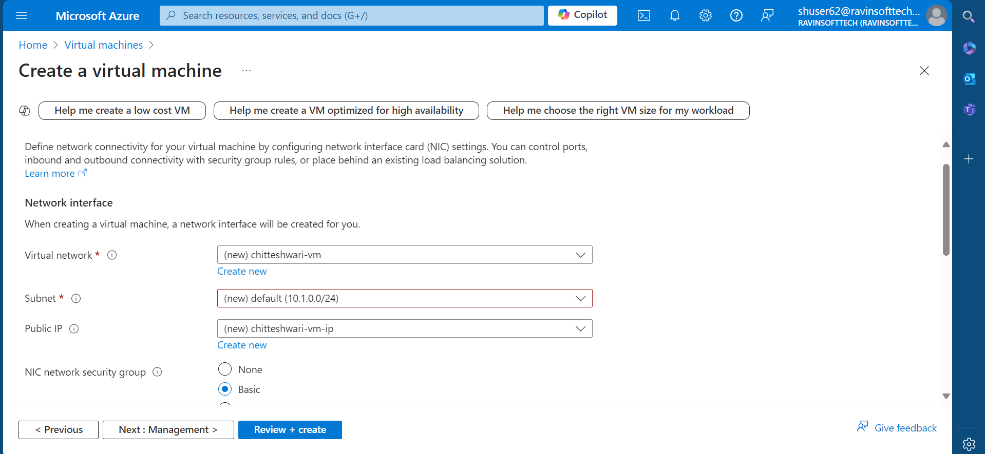

Create the VM after all options are customized as per requirement. Deploy the VM and connect to it on Windows OS using RDP (Remote Desktop Protocol) by using the public IP for the newly created VM.

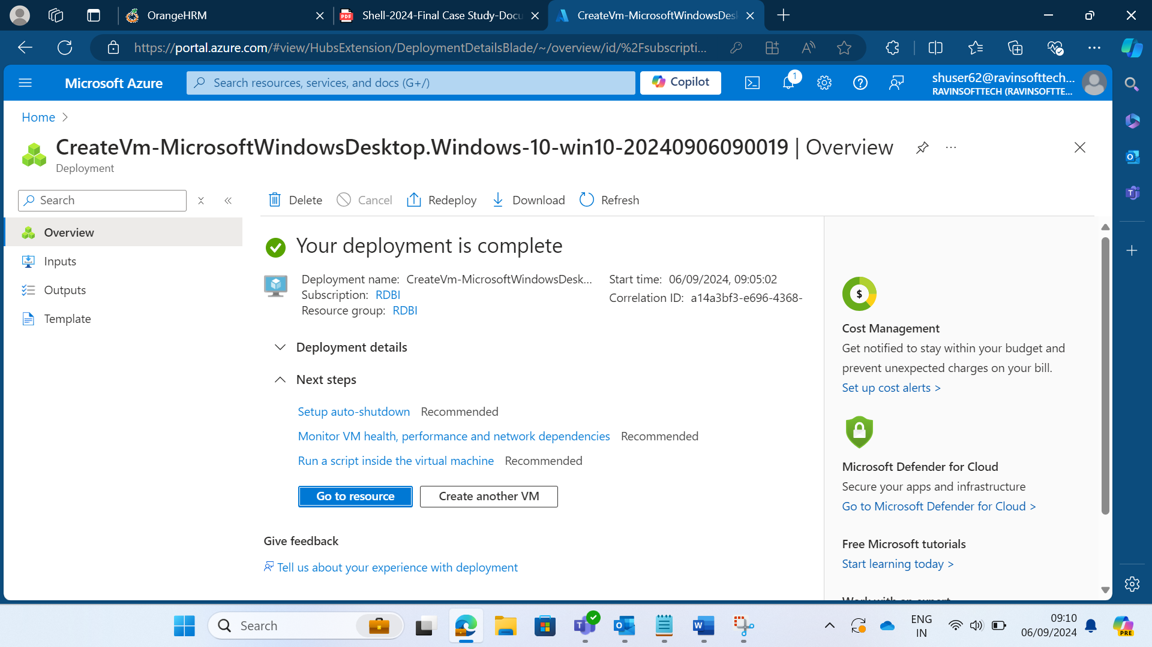

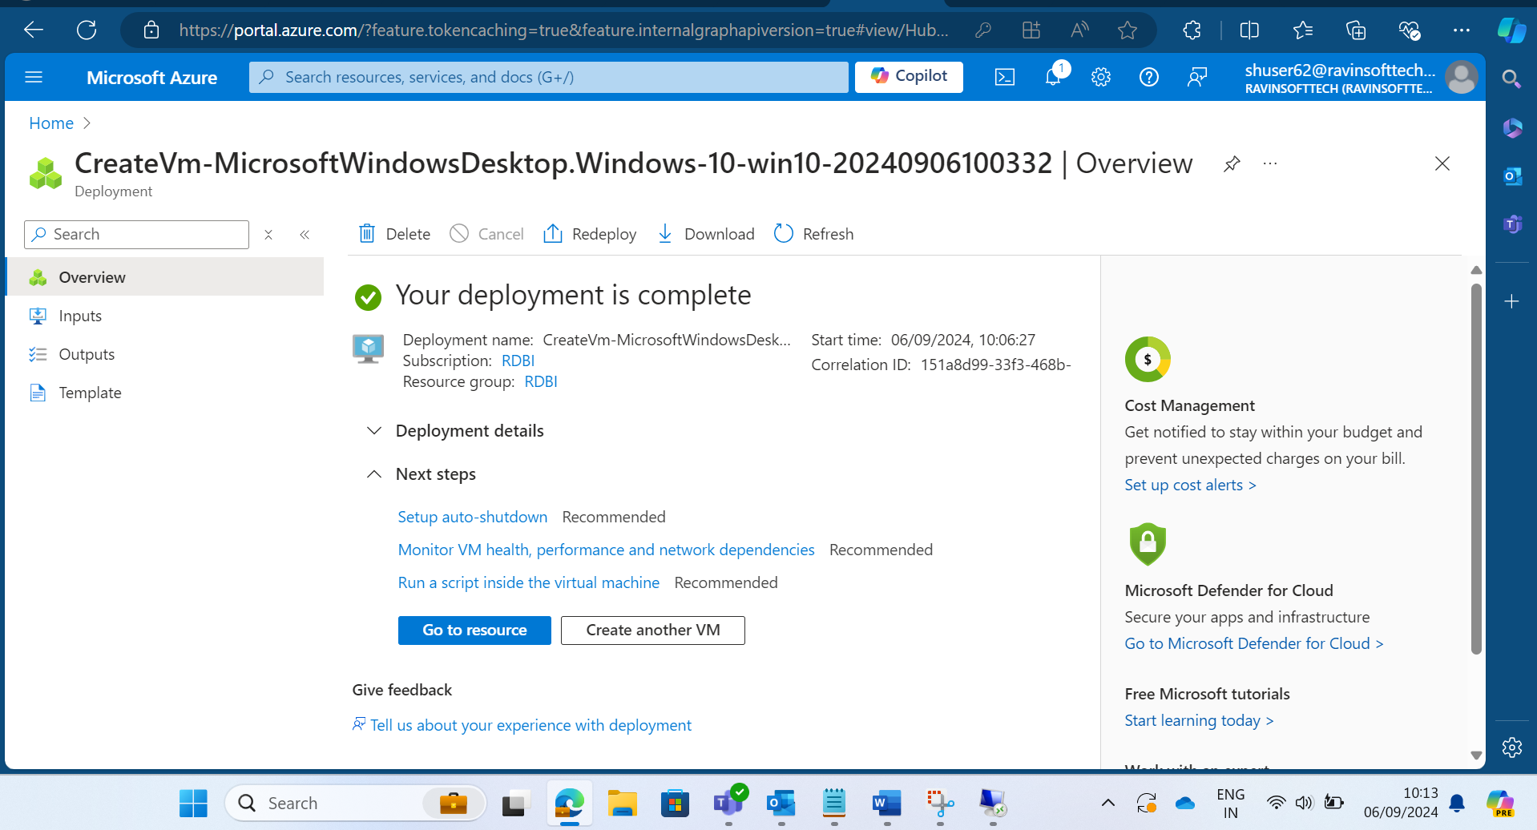

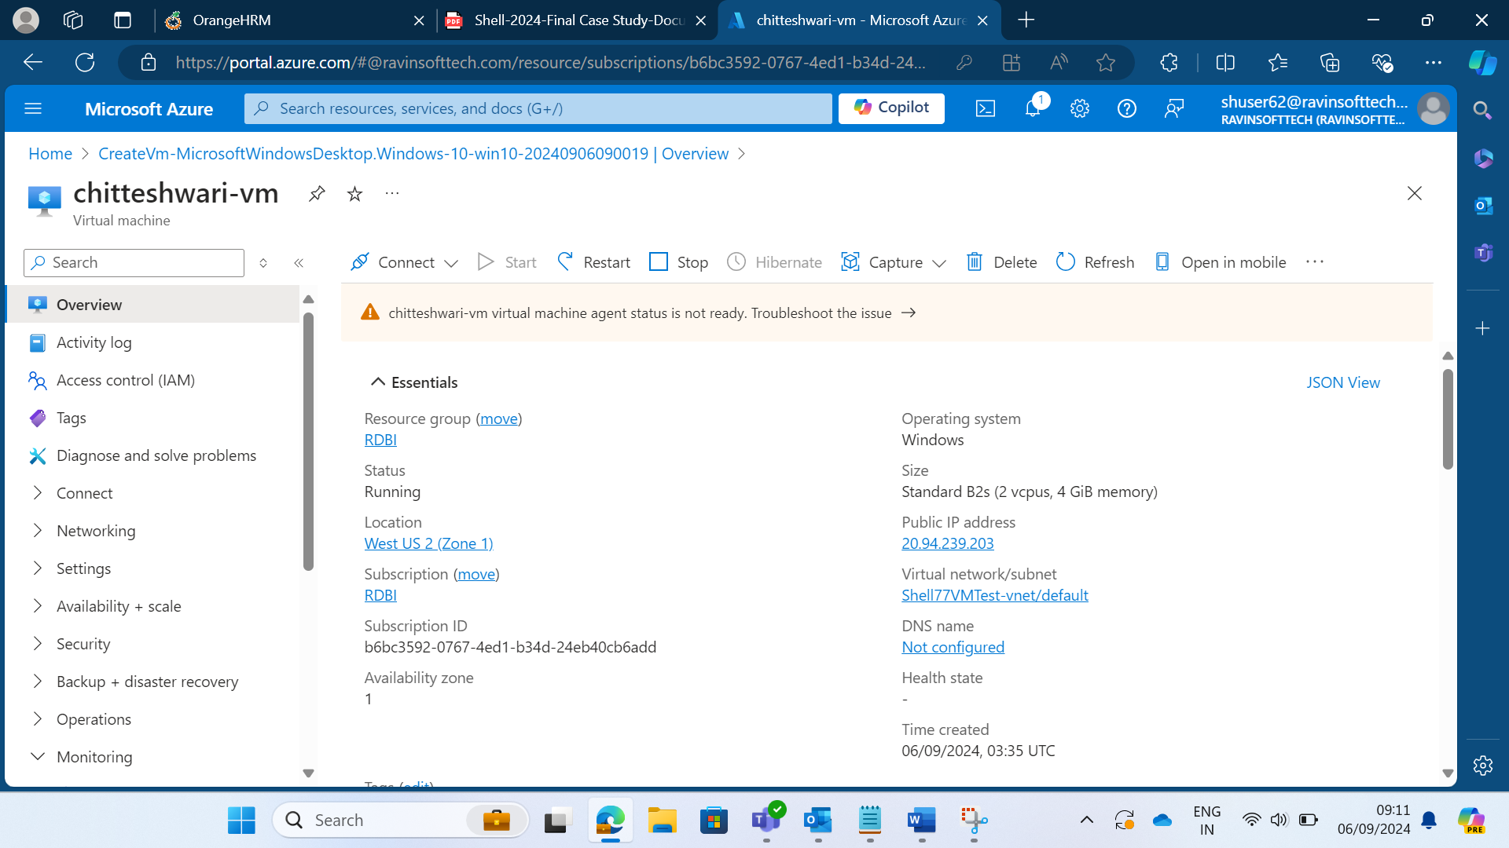

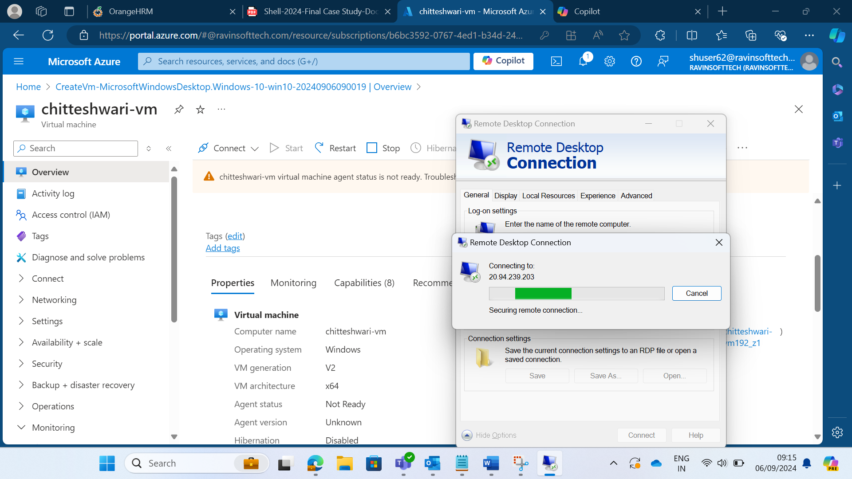

* **TASK 2: AZURE DEVOPS USER STORIES FOR HRM WEBSITE**

For the leave management module of the Orange HRM website, the following has been created:

* 1 sprint of 10 days
* 1 epic
* 5 user stories with story points and priorities with different statuses
* 2 tasks per user story (1 development task and one QA Testing task) with the estimated number of hours
* 5 Test cases per user story
* Bugs (Defect report) related to the test cases mentioned for the user story

First created an organization and project on Azure Devops.

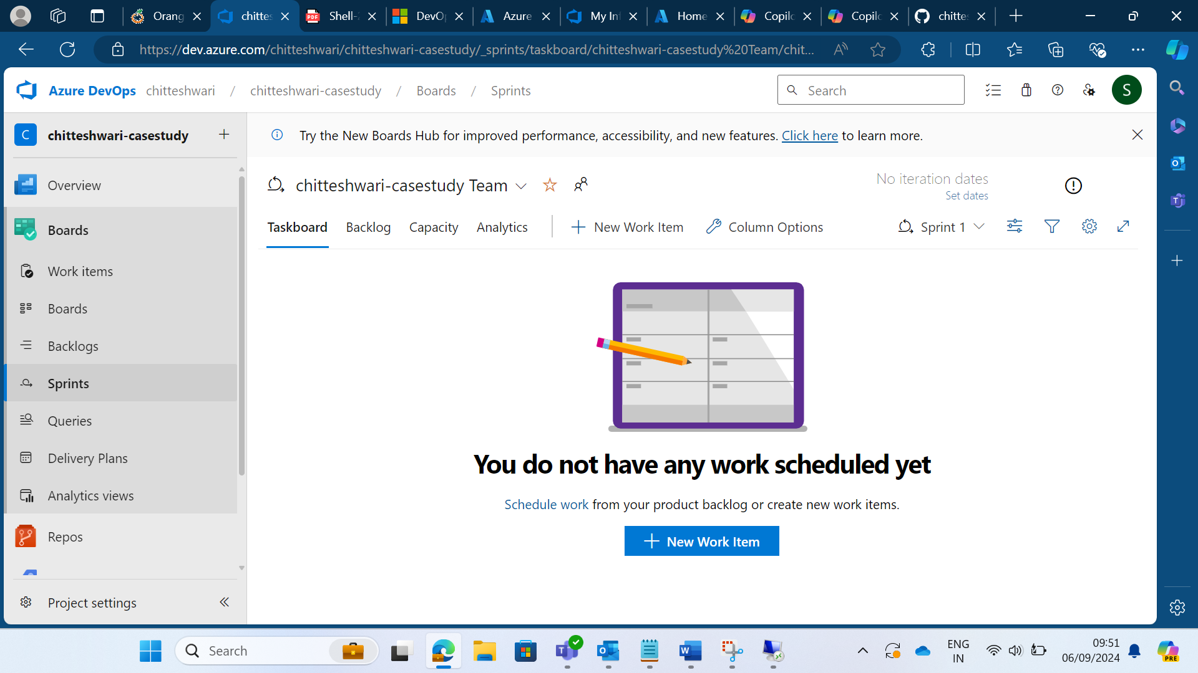

The overall board view of the stories created:

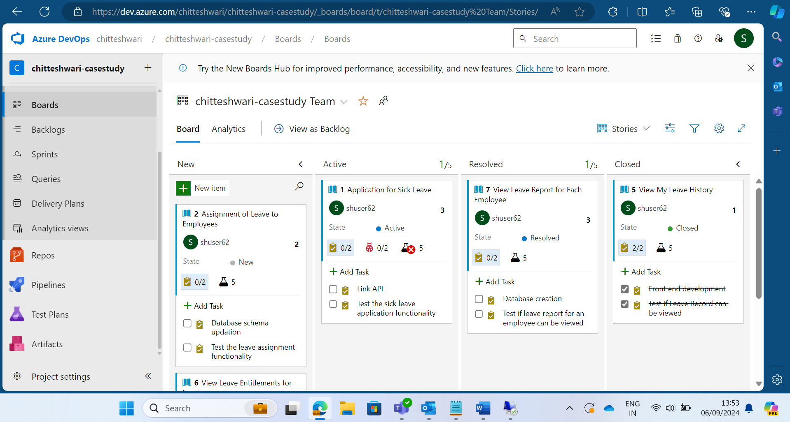

Epic:

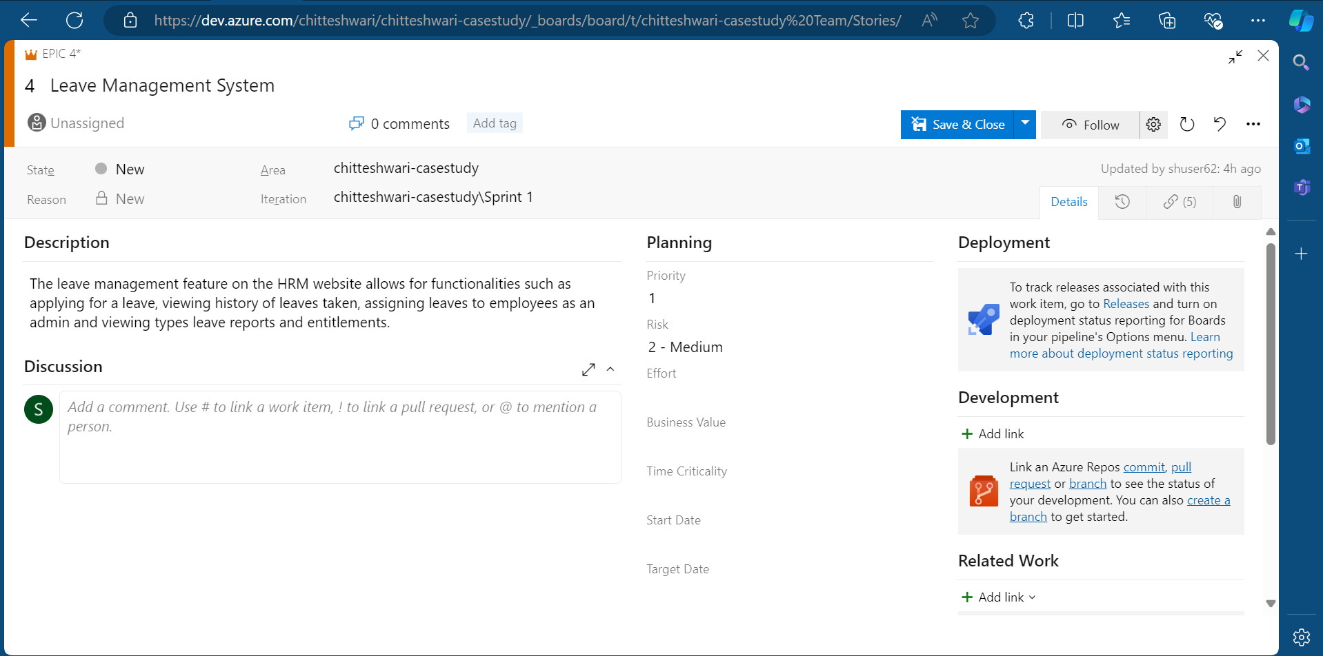

Sprint:

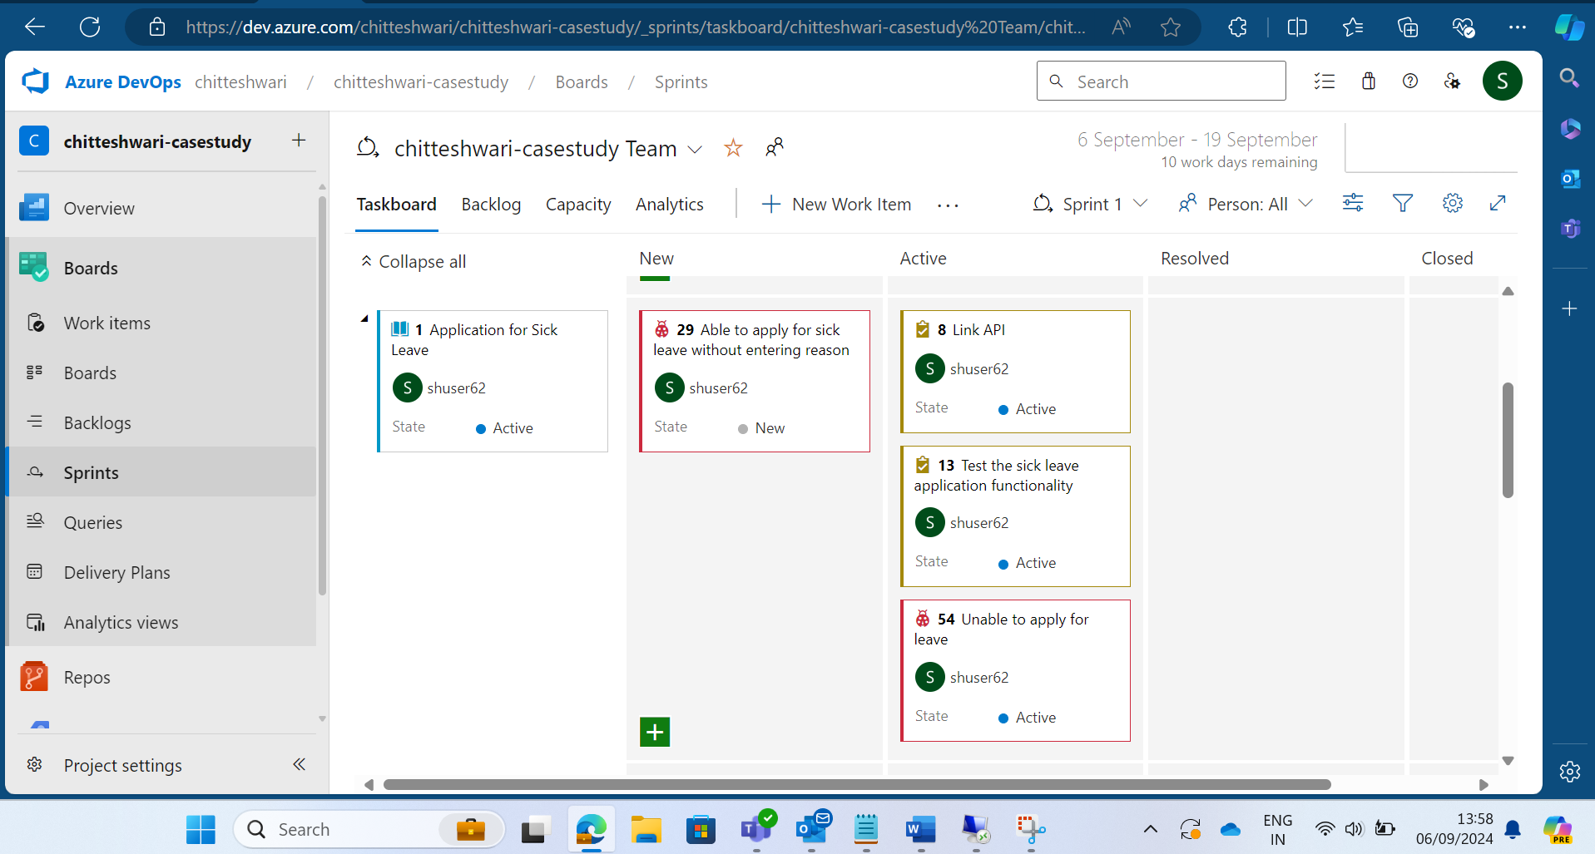

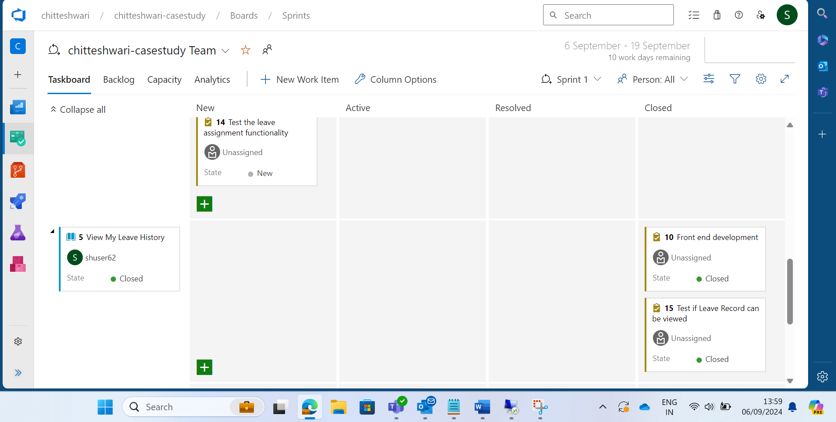

User stories: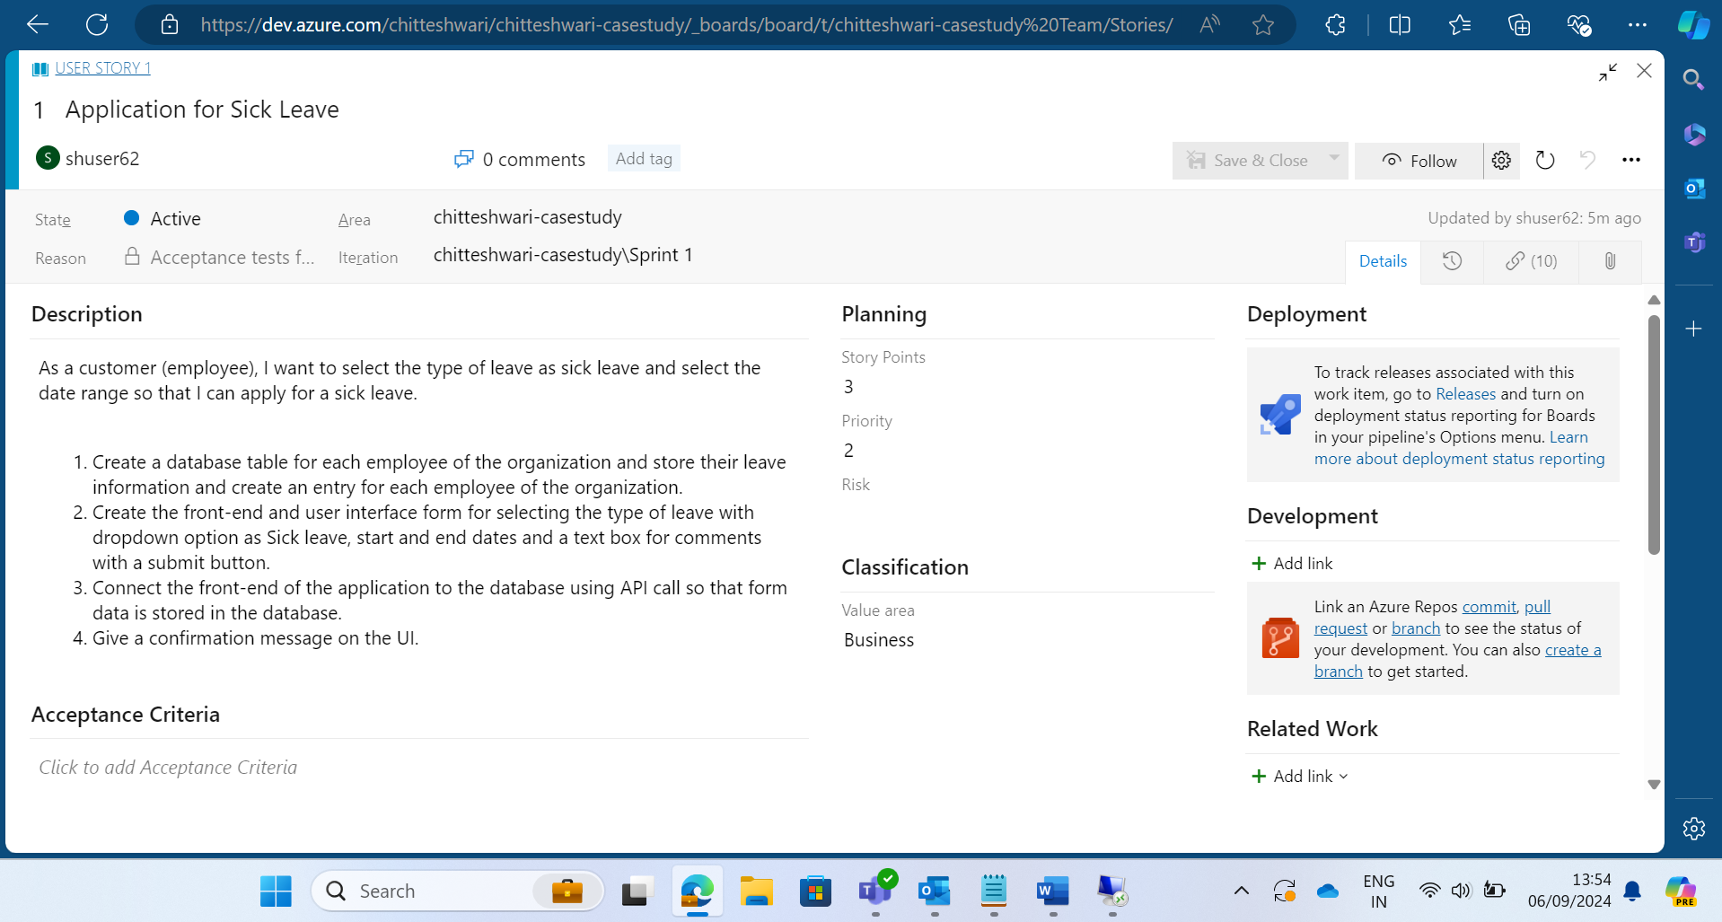

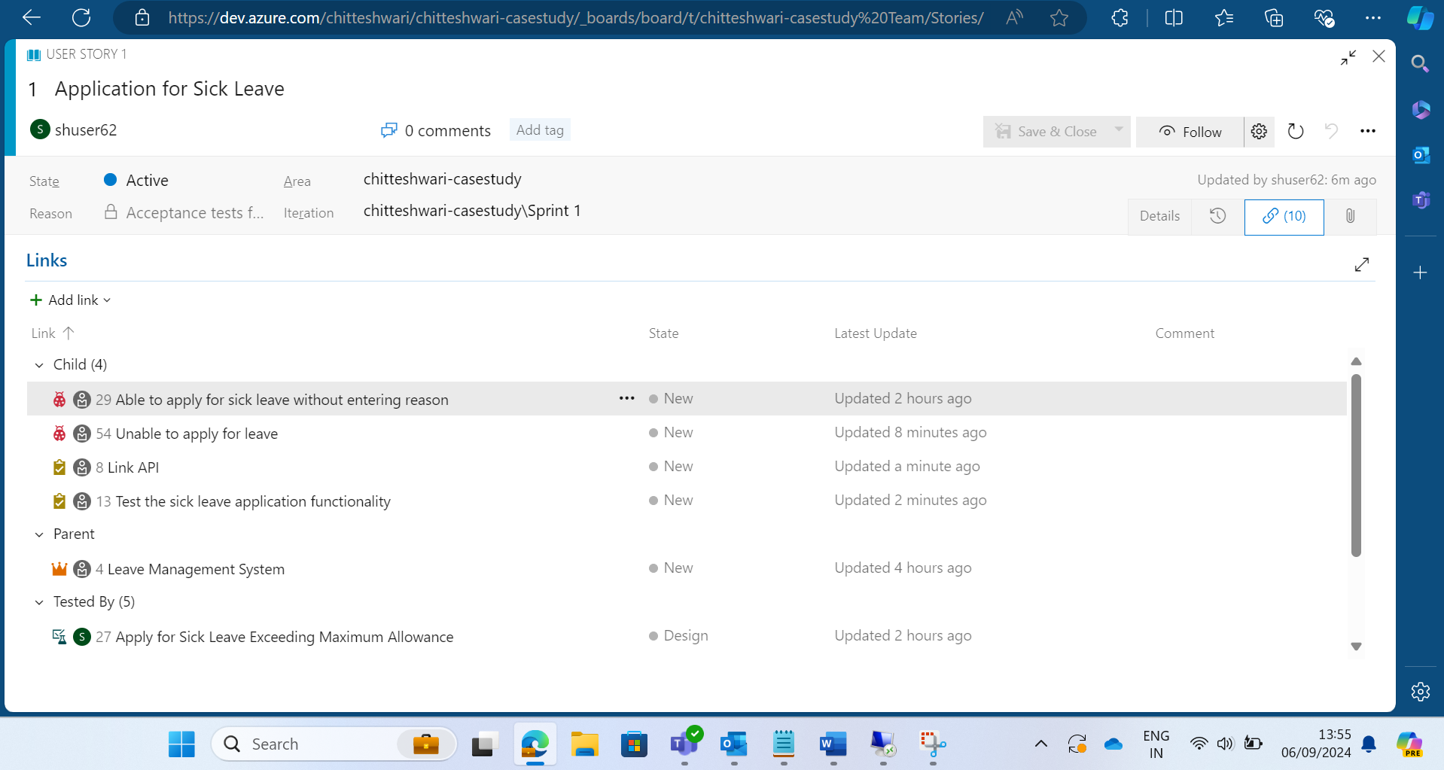

Task for user story:

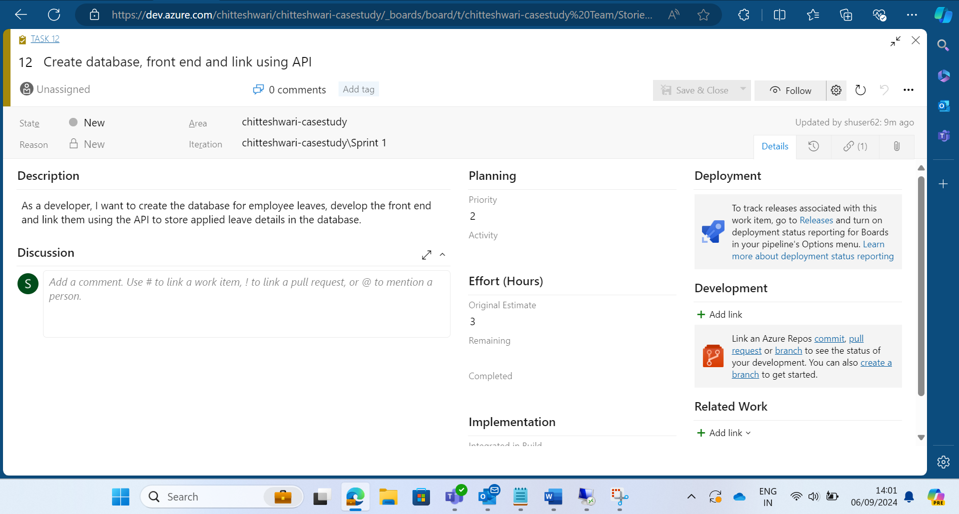

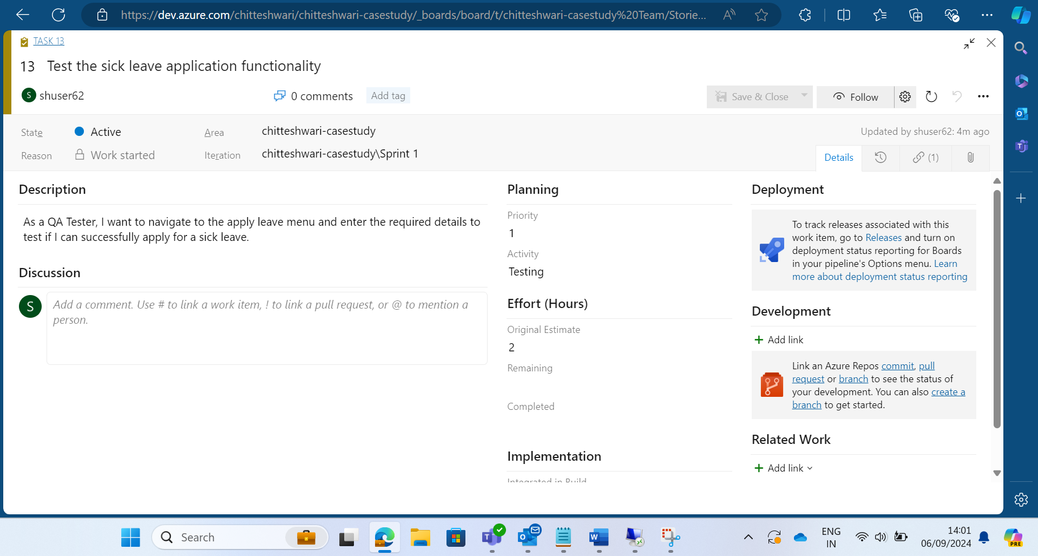

Test case for the user story:

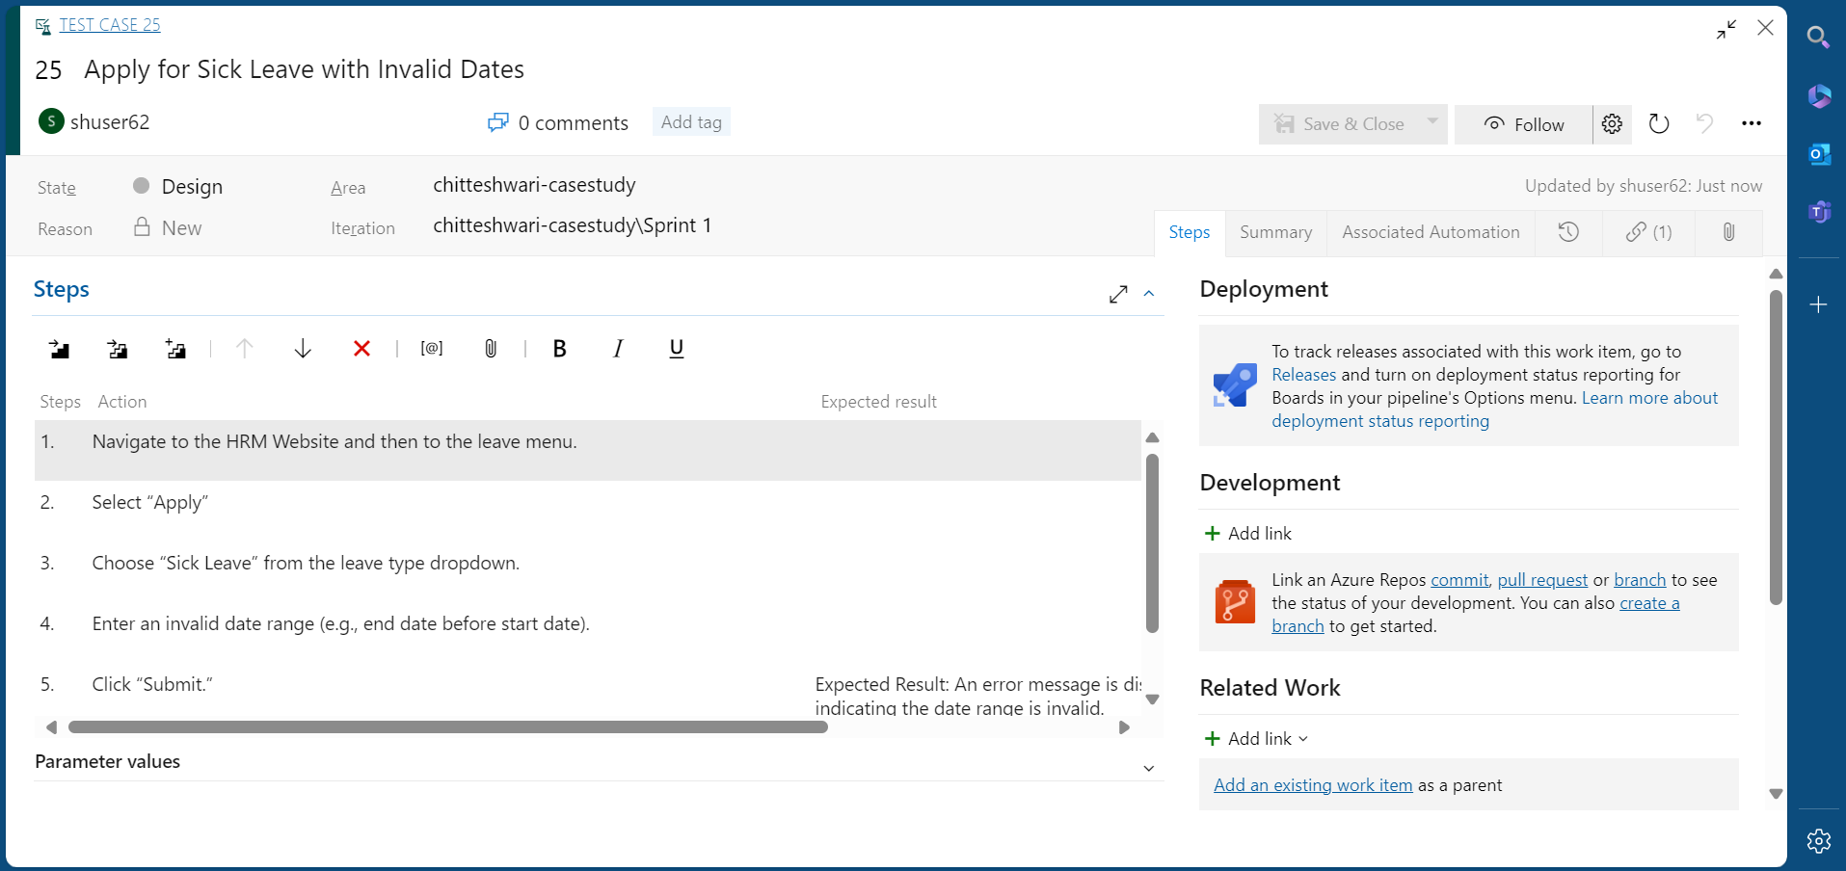

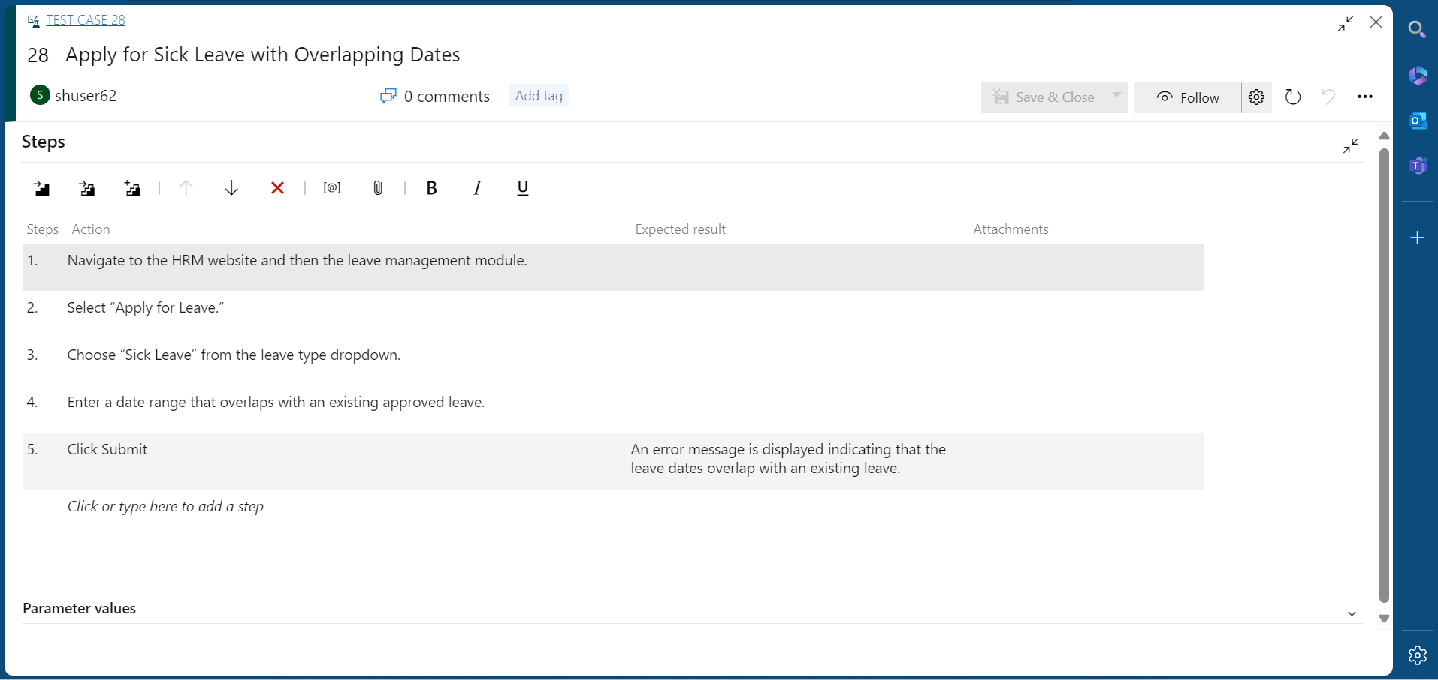

Linked the test case to the user story:

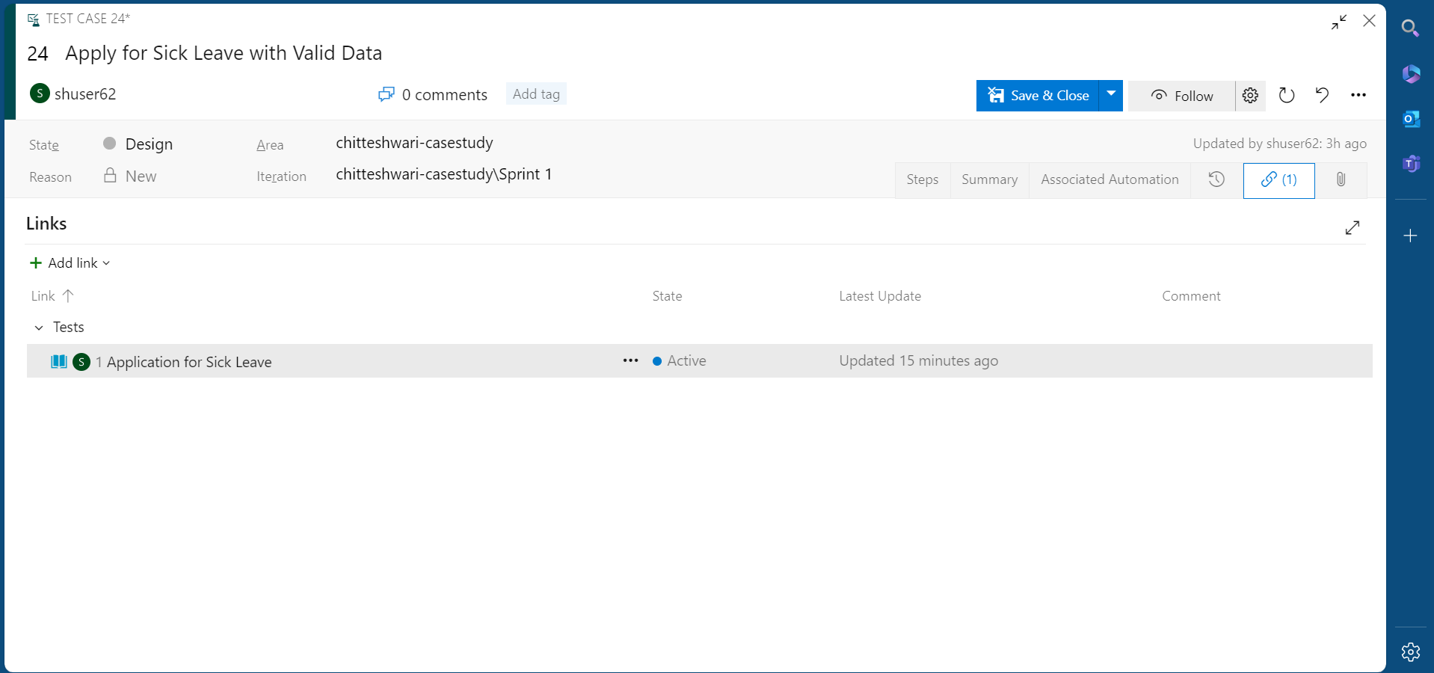

Bug for the user story related to the test case:

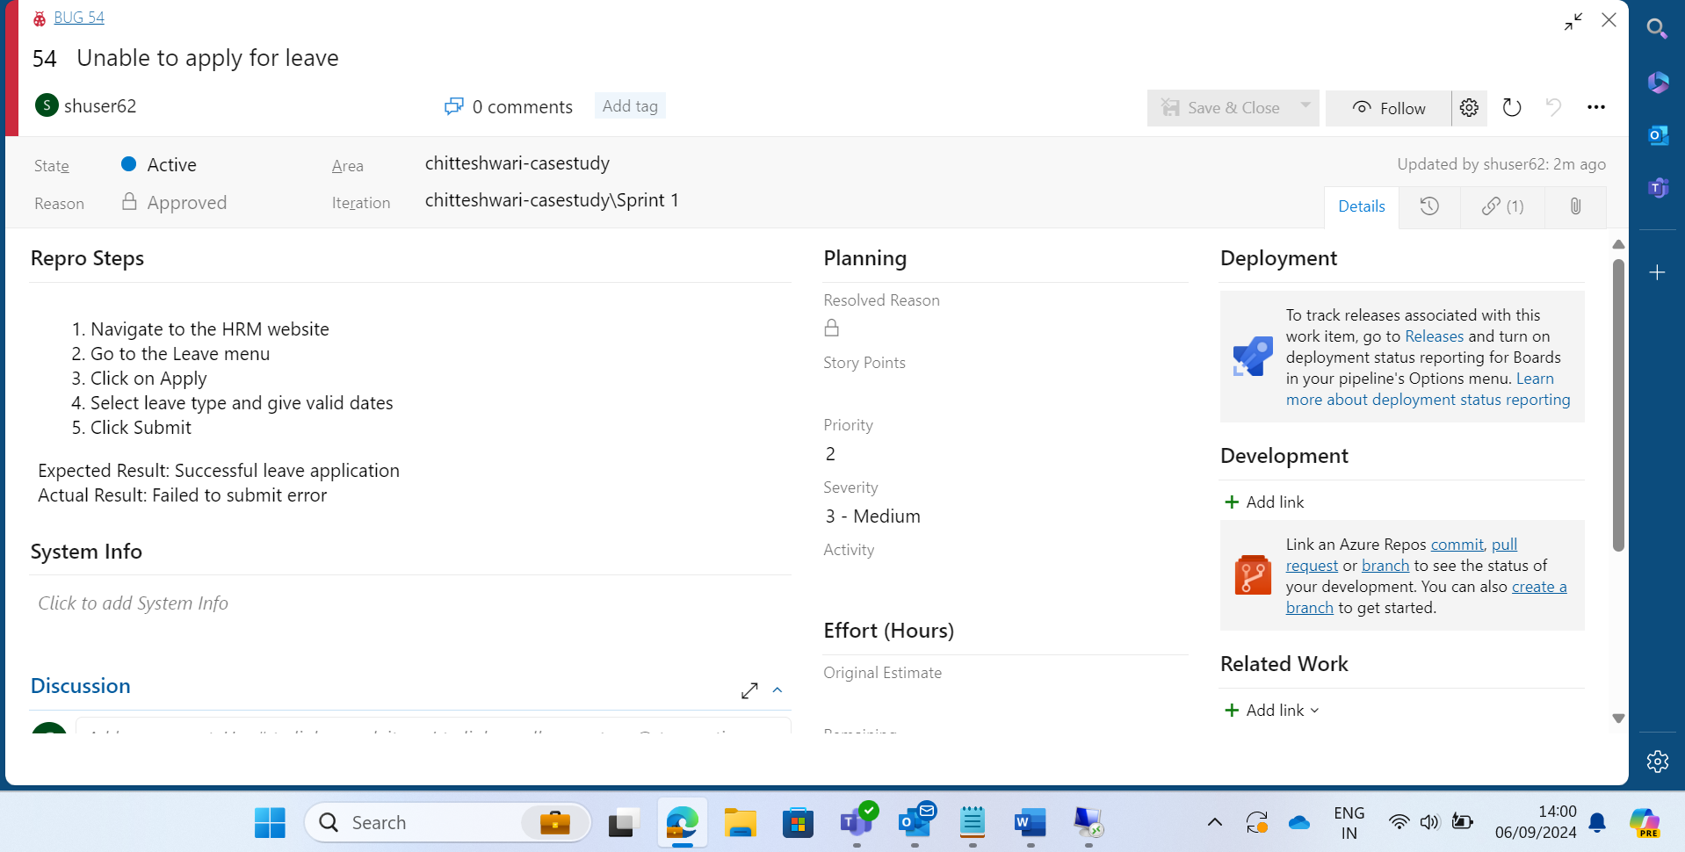

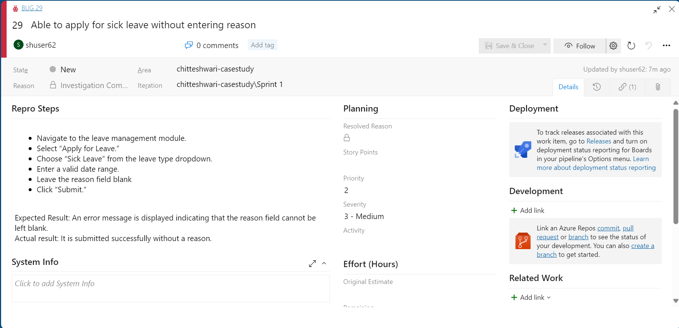

* **TASK 3: CI/CD PIPELINE USING GITHUB ACTIONS**

Using the VM created on Azure, create a new Github repository and clone it to the local system.

Application created:

A Python application for a calculator, along with unit tests in Python and a YAML deployment file by creating a new branch (calculator-develop) from the main branch on Visual Studio Code. YAML file is created in the directory “.github/workflows”

Stage the changes and commit them after signing into Git.

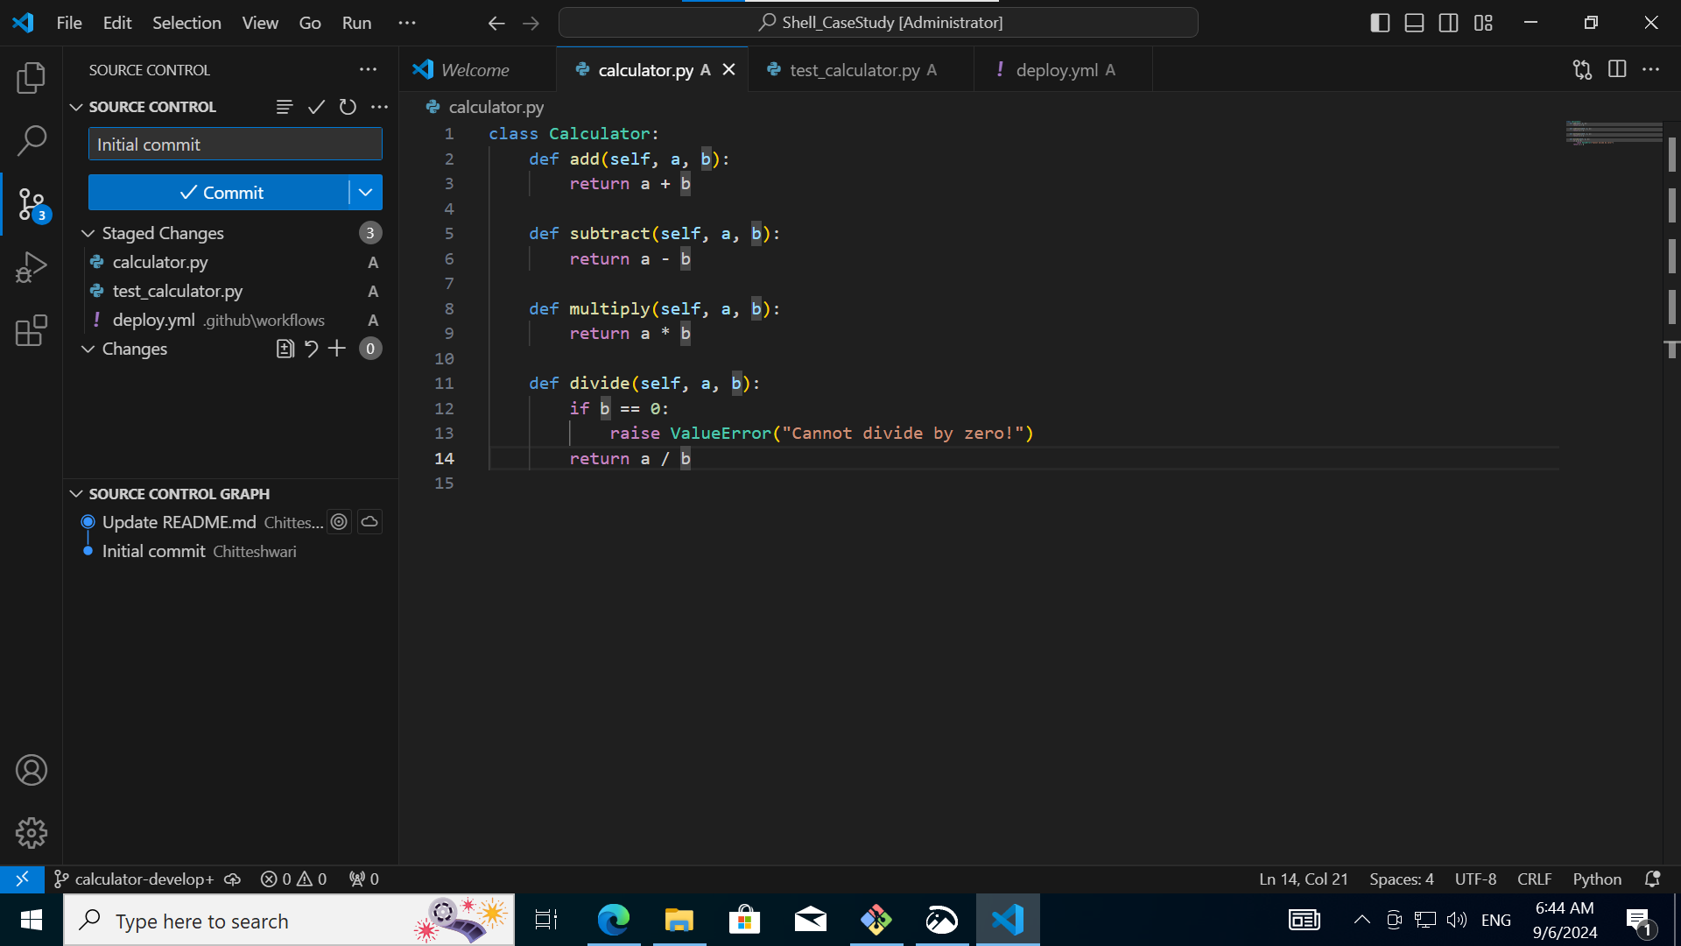

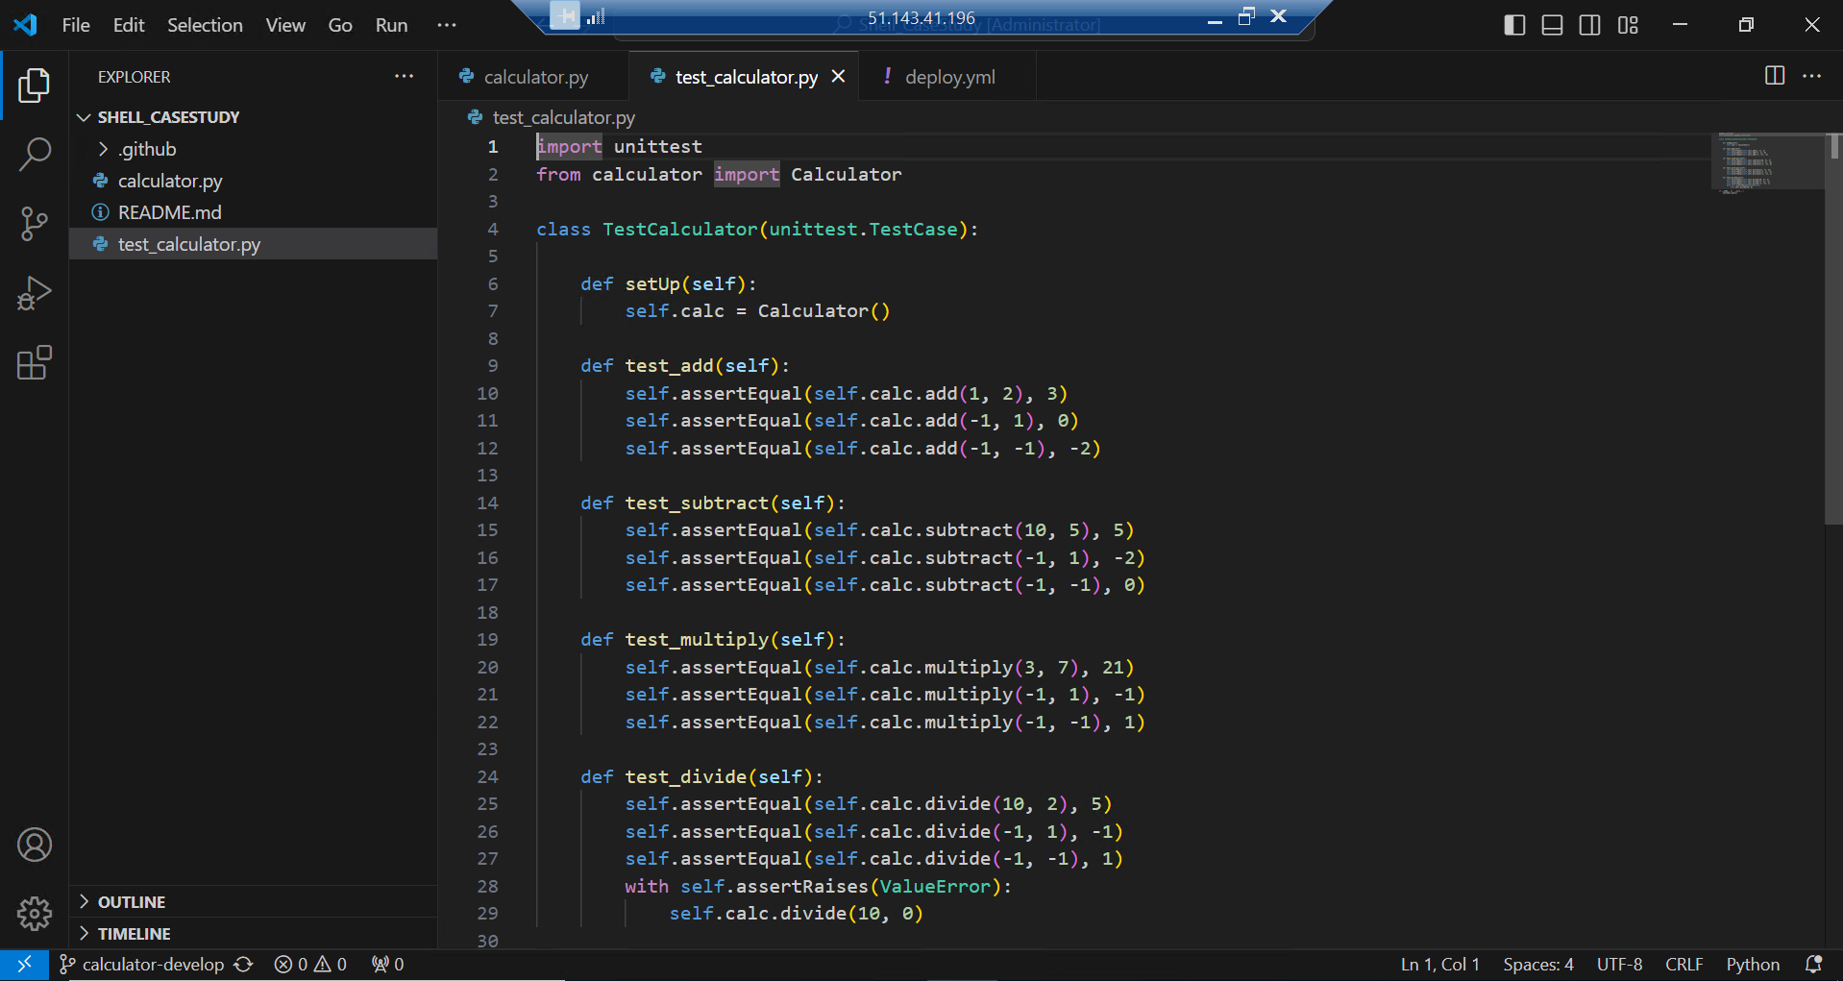

A push is created on Github for the repo.

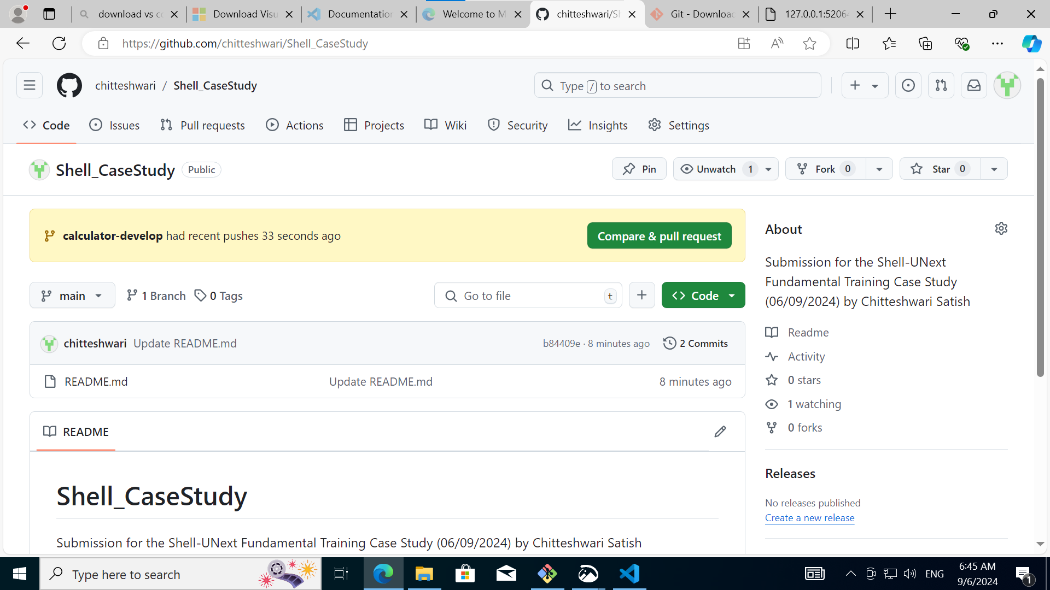

Create a pull request to the main branch.

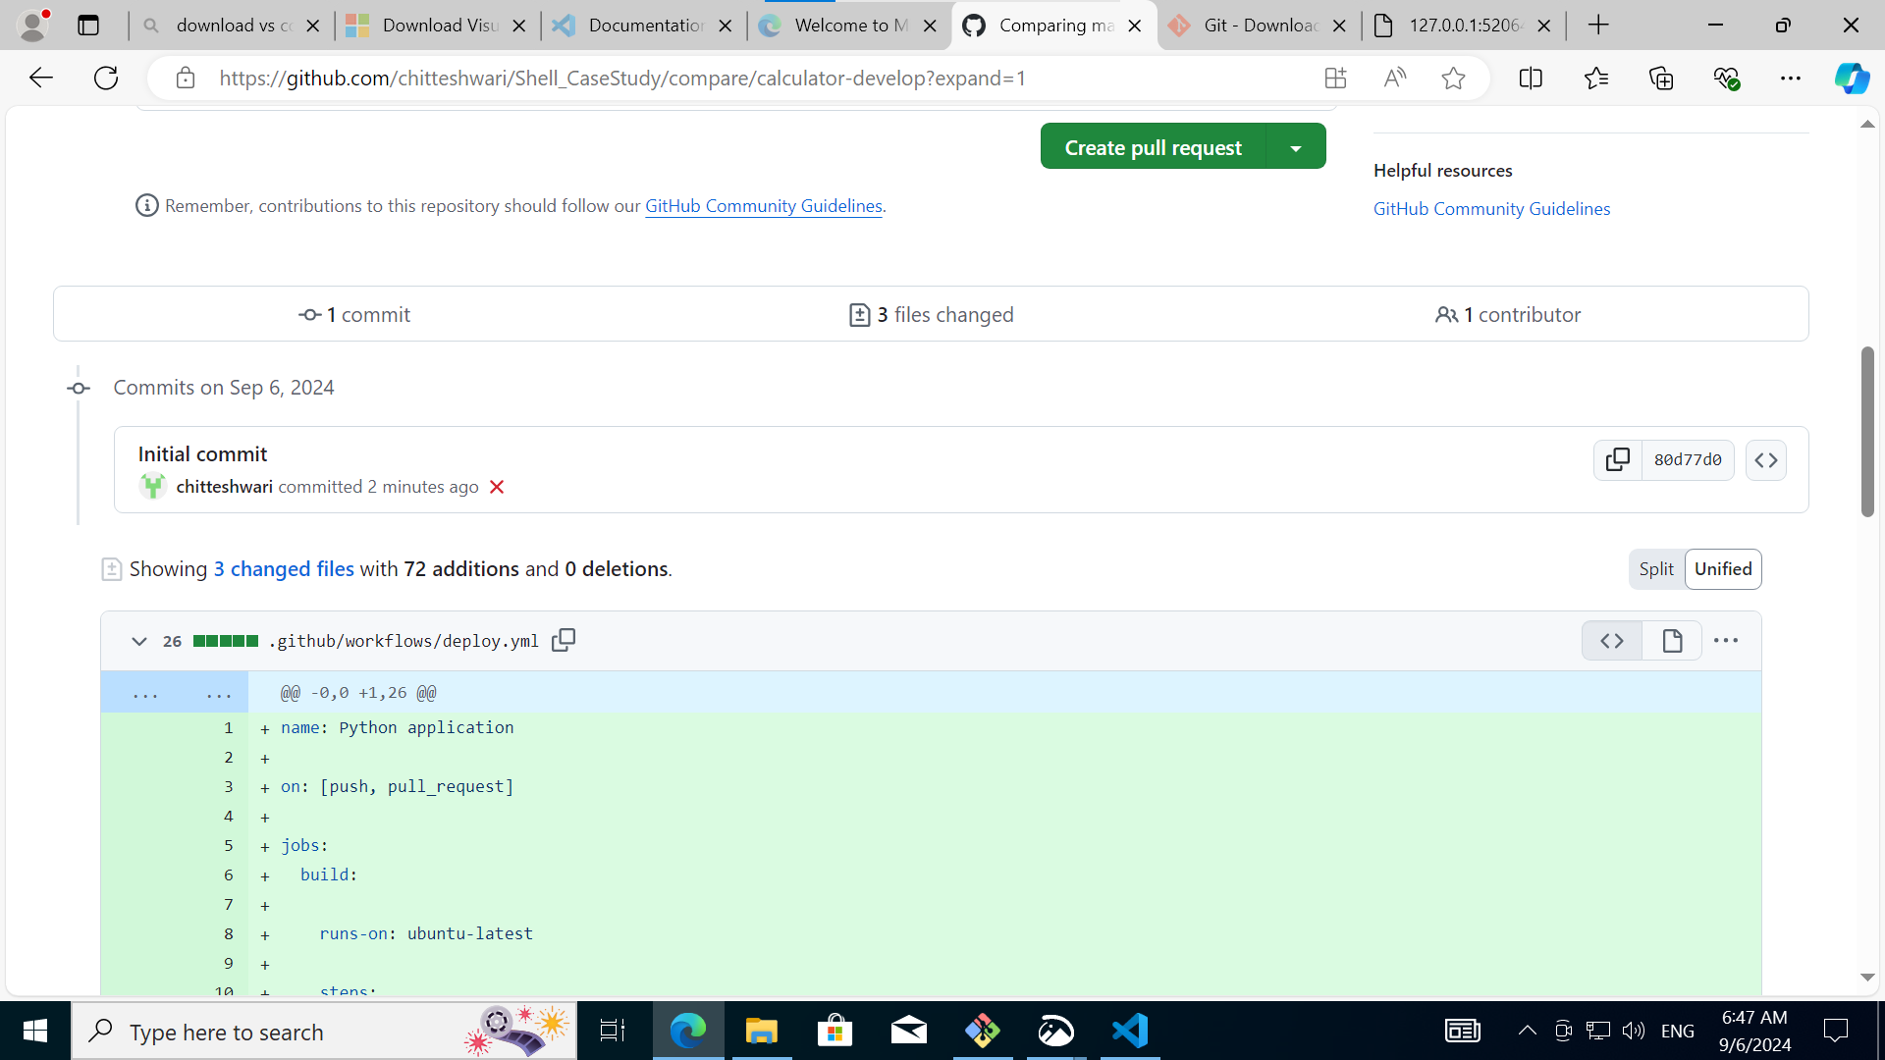

Merge the two branches.

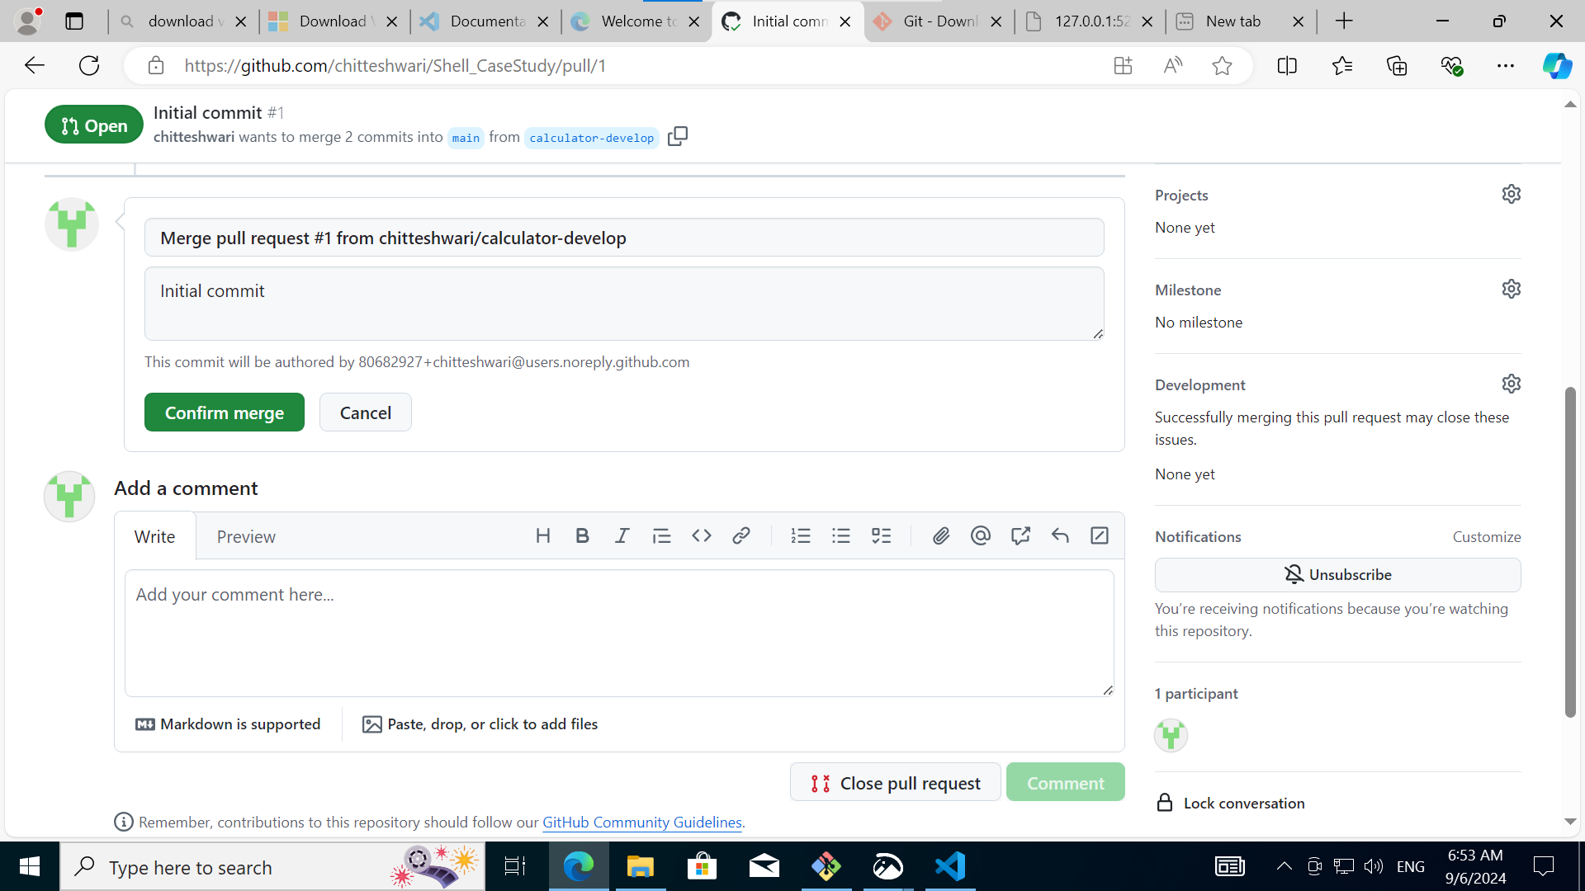

Since the checks have been passed on Github, the merge is successful.

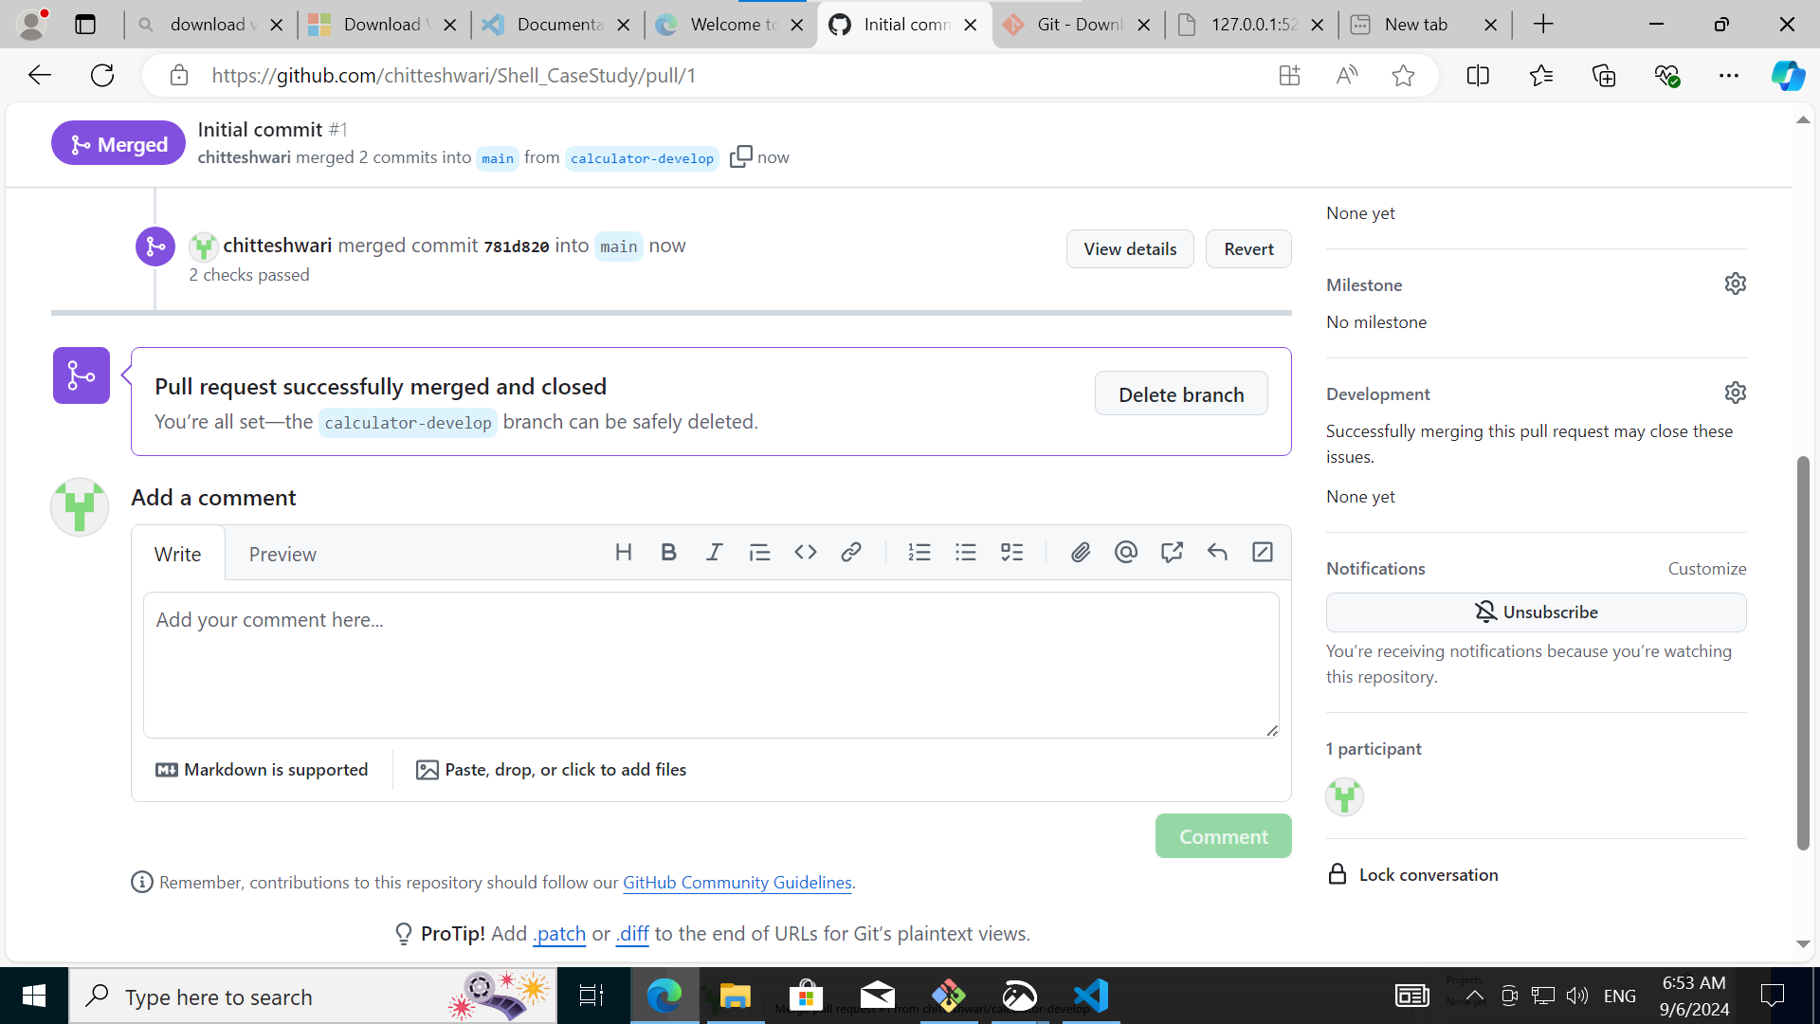

Change settings to allow Github pages to be built from the Main branch.

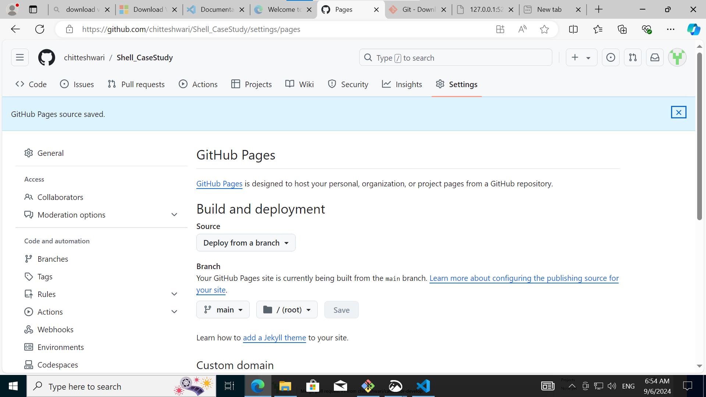

In Github Actions, the deployment is now successfully completed and a link is created for the Github page. Any changed code is automatically tested, integrated and deployed to the build.

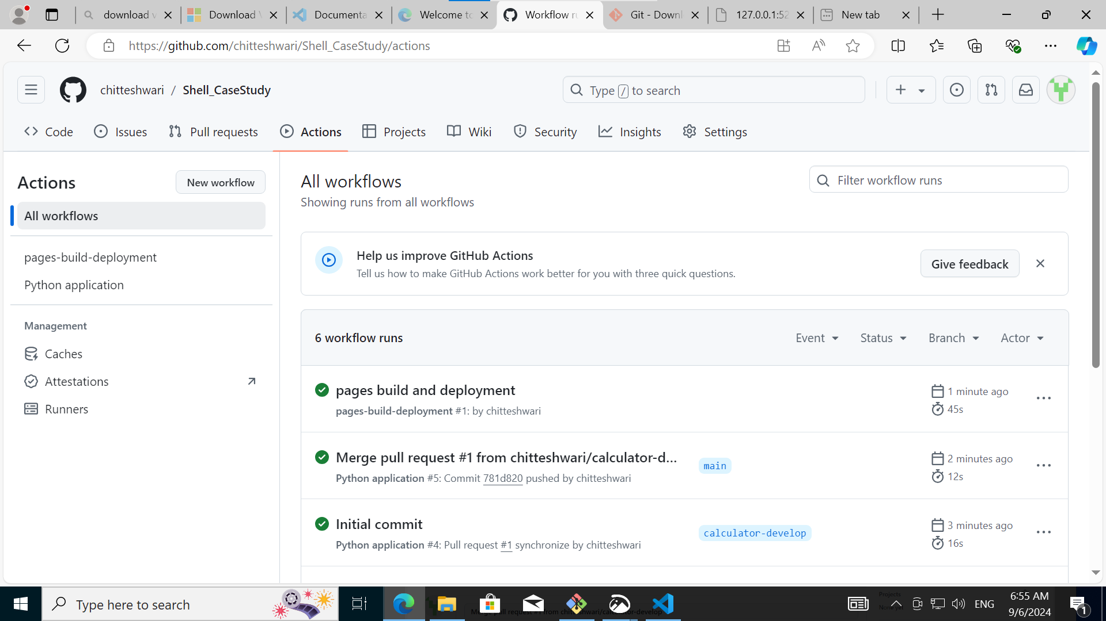

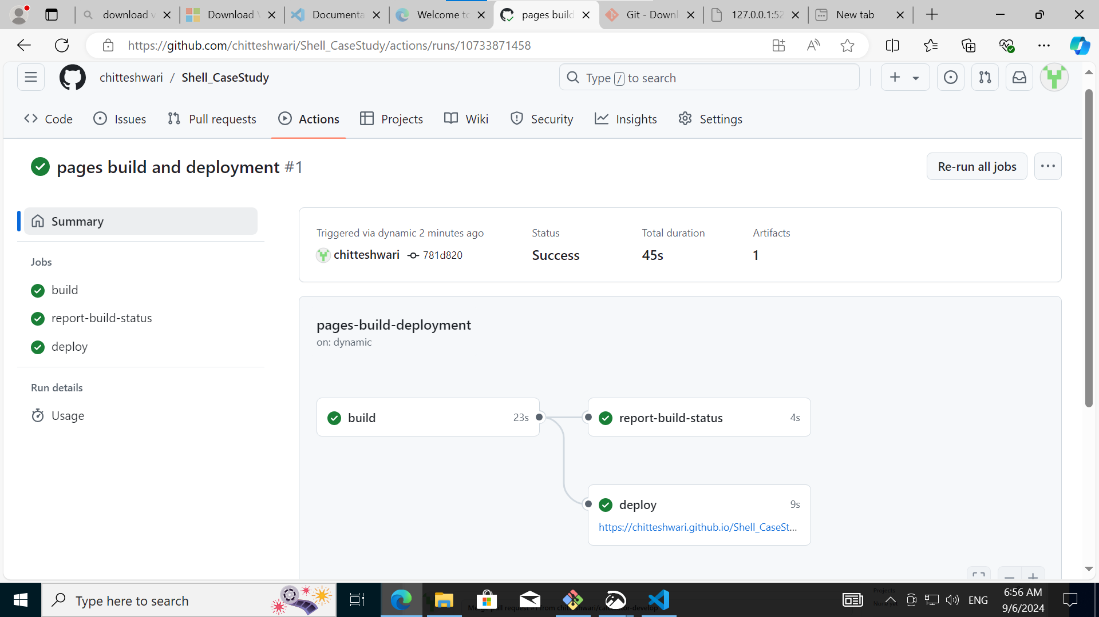

The Github Page URL displays the Readme file for the project.

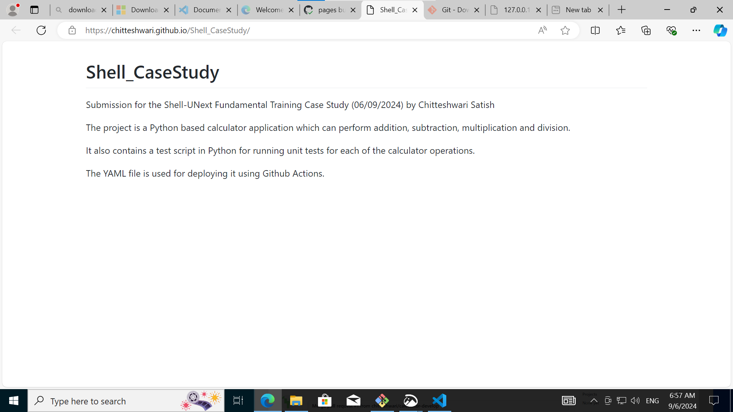

The new files and changes are all now available on the main branch itself.

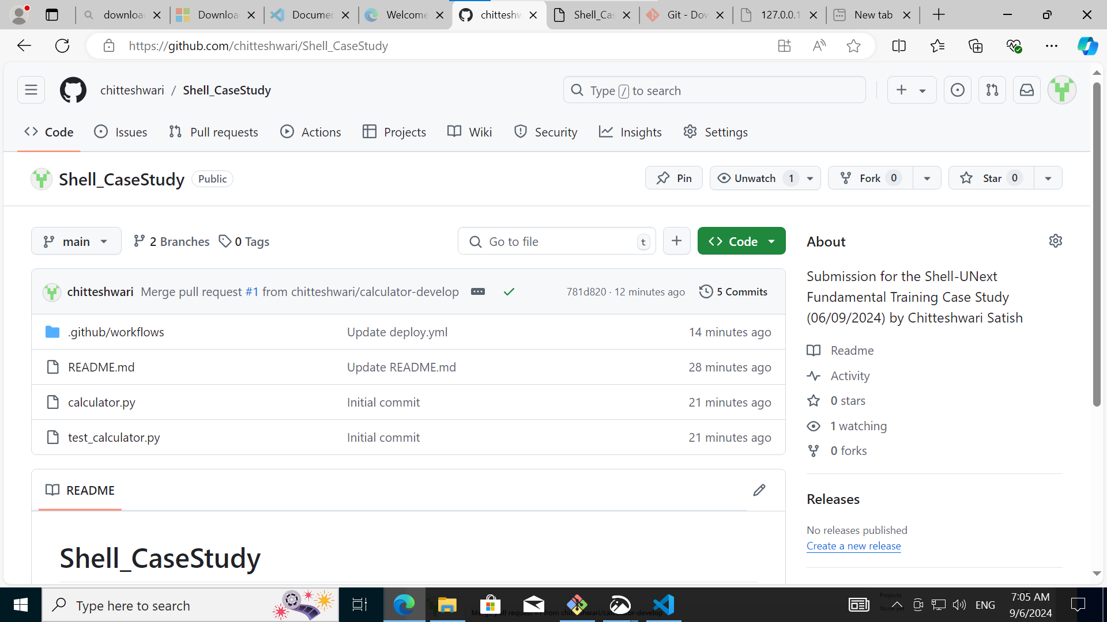

Therefore, all the tasks are successfully completed.